# IRunes

You have to implement the **IRunes** **application** – a simple **music store application**.

## Technological Requirements

* Use the **SIS**
* Use **Entity Framework Core**

The Technological Requirements are **ABSOLUTE**. If you do not follow them, you will **NOT** be scored for other Requirements.

Now that you know the **Technological Requirements**, let us see what the **Functional Requirements** are.

# Database Requirements

You have been tasked to implement a simple application, using the Web Server. The application imitates a **store** for **Music Albums** and **Music Tracks**. You will see the functionality – described below.

The first thing you need to do is implement the Database entities. Use Entity Framework Core, and implement the following entities:

## User

* Id – a string (**GuID**), Primary key
* Username – a string with **min length 4** and **max length 10 (inclusive) (required)**
* Password – a string with **min length** **6** and **max length 20 (inclusive)** - hashed in the database (**required**)
* Email – a string **(required)**

## Album

* Id – a string (**GuID**), Primary key
* Name – a string with **min length 4** and **max length 20 (inclusive) (required)**
* Cover – a string (a **link** to an **image**) **(required)**
* Price – a decimal (**sum** of all Tracks’ **prices**, **reduced** by **13%**) **(required)**
* Tracks – a **collection** of Tracks

## Track

* Id – a string (**GuID**), Primary key
* Name – a string with **min length 4** and **max length 20 (inclusive) (required)**
* Link – a string (a **link** to a **video**) **(required)**
* Price – a decimal **(required)**

# Templates

You will be shown how the **template looked before**, and **how it should look now**. Style it **using Bootstrap**, to match the given screenshot. Be as precise as you can.

## Index (guest, logged-out) (route=”/”)

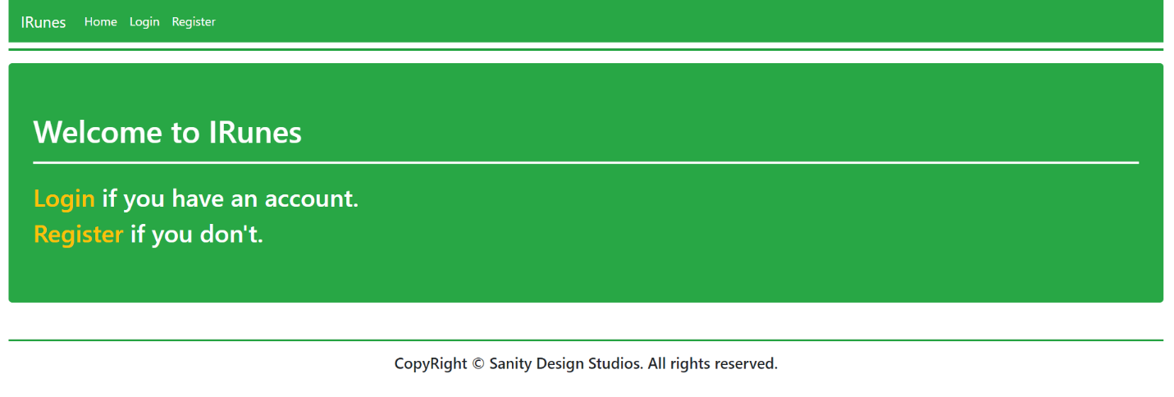

## Login (guest, logged-out) (route=”/Users/Login”)

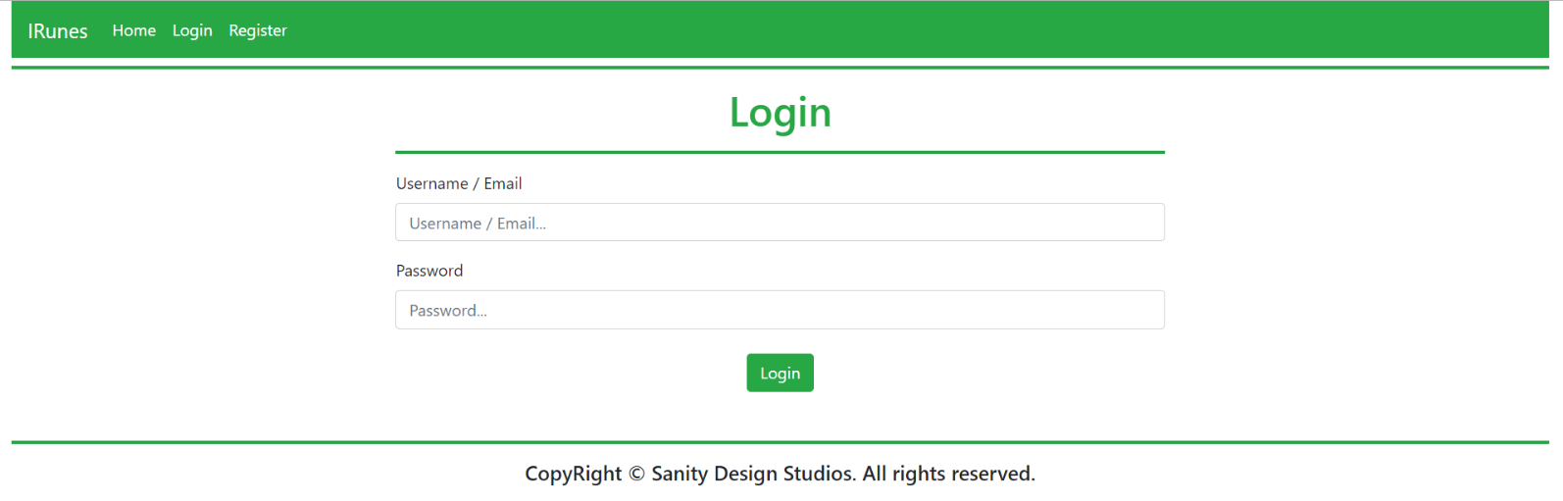

## Register (guest, logged-out) (route=”/Users/Register”)

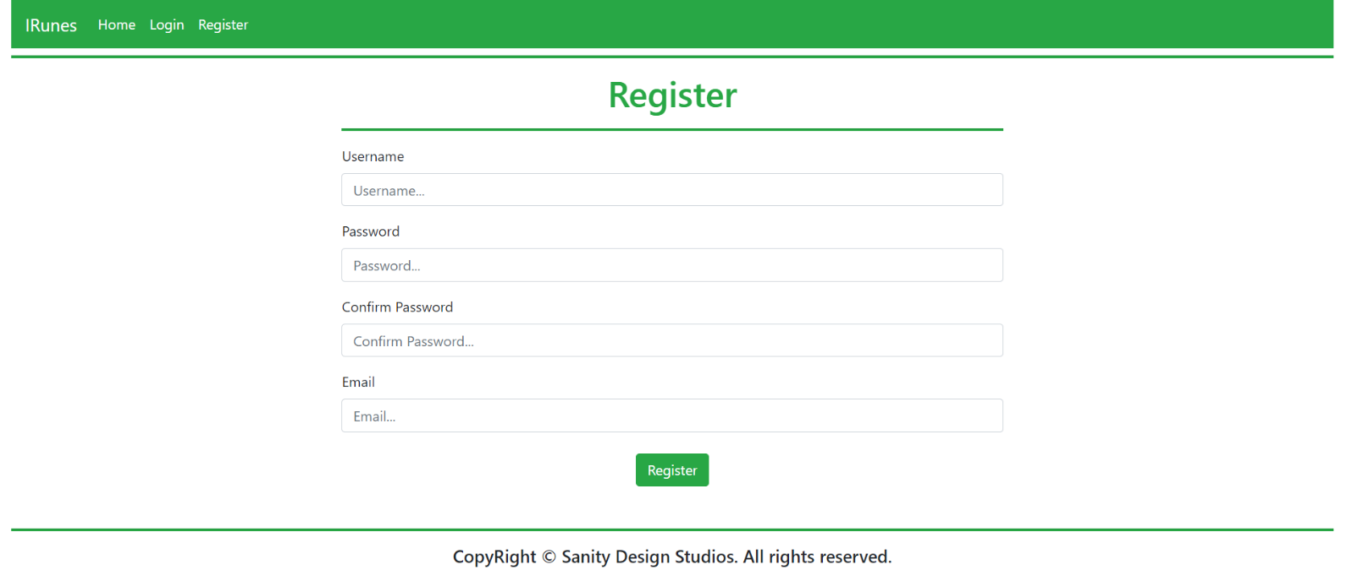

## Index (user, logged-in) (route=”/Home/Index”, route=”/”)

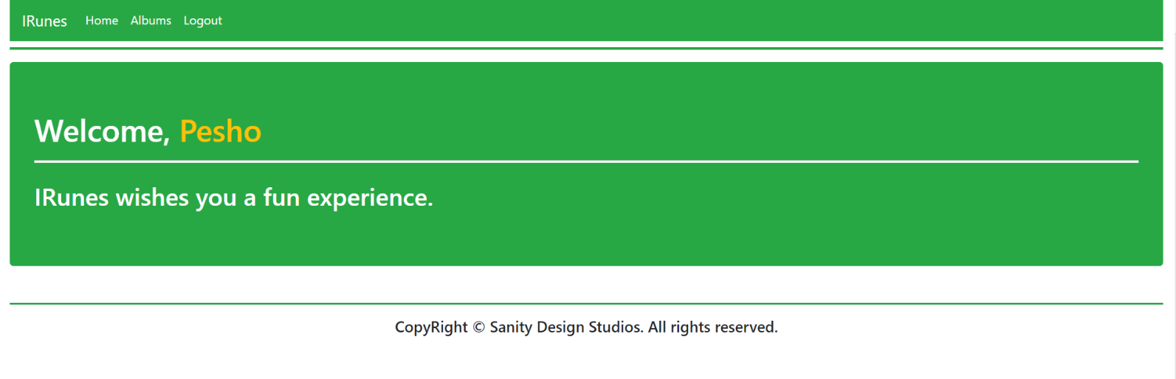

## All Albums (user, logged-in) (route=”/Albums/All”)

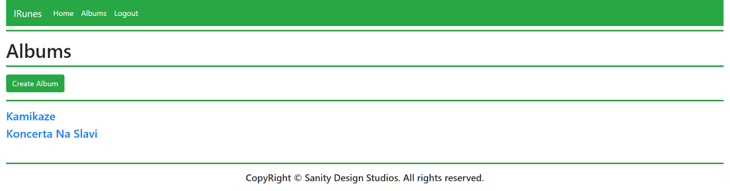

## Album Create (user, logged-in) (route=”/Albums/Create”)

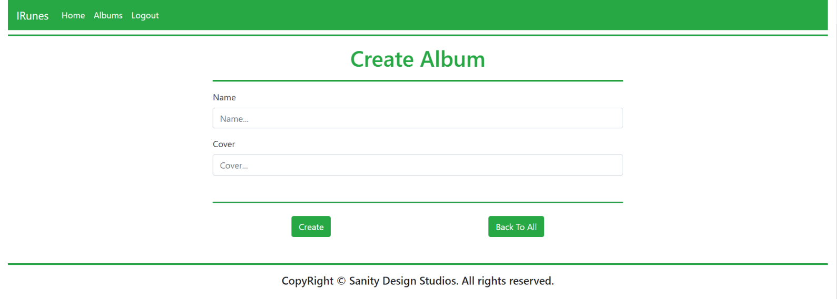

## Album Details (user, logged-in) (route=”/Albums/Details?id={albumId}”)

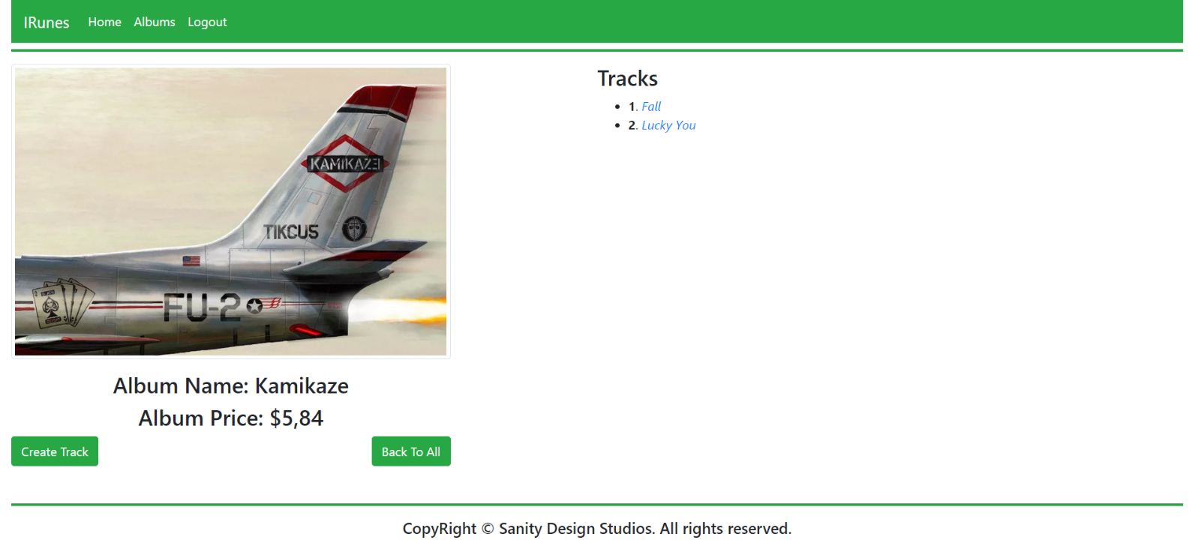

## Track Create (user, logged-in) (route=”/Tracks/Create?albumId={albumId}”)

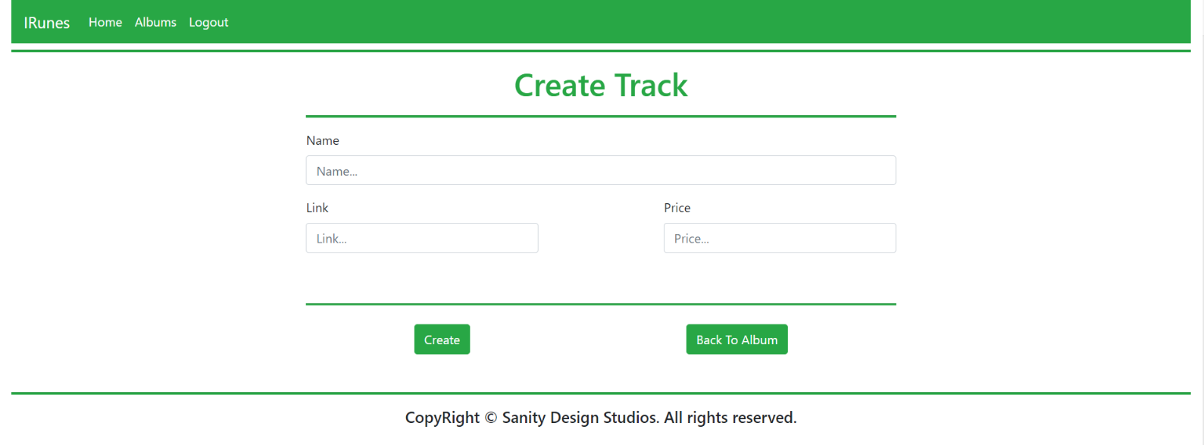

## Track Details (user, logged-in) (route=”/Tracks/Details?albumId={albumId}&trackId={trackId}”)

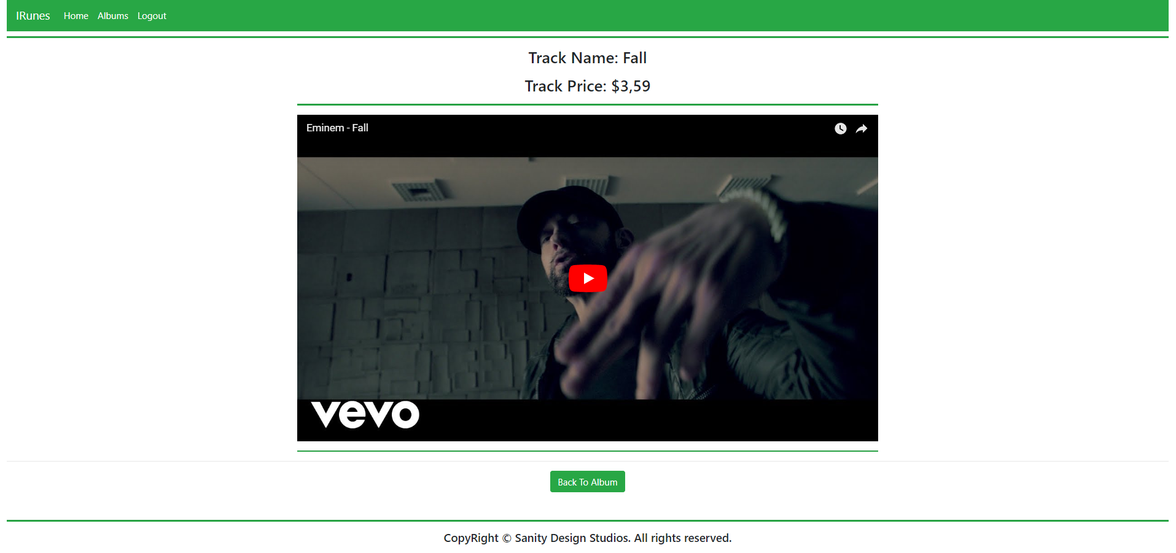

# Functional Requirements

The functional requirements are quite simple.

## Users

The application should provide guests (logged-out) with the **functionality** to access:

* The Guest Index Page
* The Login Page and Functionality
* The Register Page and Functionality

The application should provide users (logged-in) with the **functionality** to access:

* The User Index Page
* The All Albums Page
* The Album Create Page
* The Album Details Page
* The Track Create Page
* The Track Details Page

## Albums

The Albums are **created** and **presented** on the All Albums Page, in a **listed format** with only their names as elements. Each **album** **name** should be a **link** which **leads** to the corresponding Album’s Details Page.

If there **are no Albums currently** in the Database, a message “There are currently no albums.” should be printed.

On the Album’s Details Page, its tracks should be **listed**, in an **indexed list**, **starting** from **1**. The **order** of **data** is **not mandatory**.

Each **track name** should be a link which leads to the corresponding Track’s Details Page.

Logged in User should be able to create a new Album.

## Tracks

The Tracks are **created** and **presented** on their Album’s Details Page. Tracks are created using the Album’s id which is passed through the **query parameters**.

When you **create** a Track, you can pass it the **iframe-ready url**, in order to make your work easier.

Logged in User should be able to create a new Track.

## Code Quality

Make sure you provide the best architecture possible. Structure your code into different classes, follow the principles of high-quality code (**SOLID**). You will be scored for the Code Quality and Architecture of your project.

## Data Validation

* In case of invalid data during the **login**, redirect to "**/Users/Login**"
* In case of invalid data during the **registration**, redirect to "**/Users/Register**"
* In case of invalid data during the **album creation**, redirect to "**/Albums/Create**"
* In case of invalid data during the **track creation**, redirect to **"/Tracks/Create?albumId={albumId}**"

## Scoring

* Database Requirements – 10 points.
* Template Requirements – 10 points.
* Functionality – 50 points.
* Security – 10 points.
* Application Structure – 10 points.
* Data Validation – 10 points.